Approaching from the interstate on US 60/Versailles Road. Proceed to the stop light at the intersection ahead.

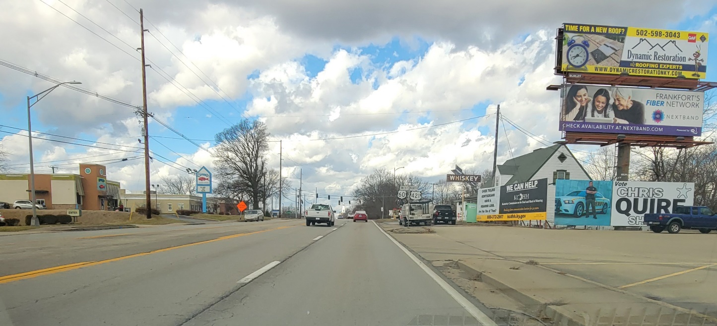

US 60/Versailles Road: Right before the stop light, get into the right turning lane. Turn Right onto Country Lane.
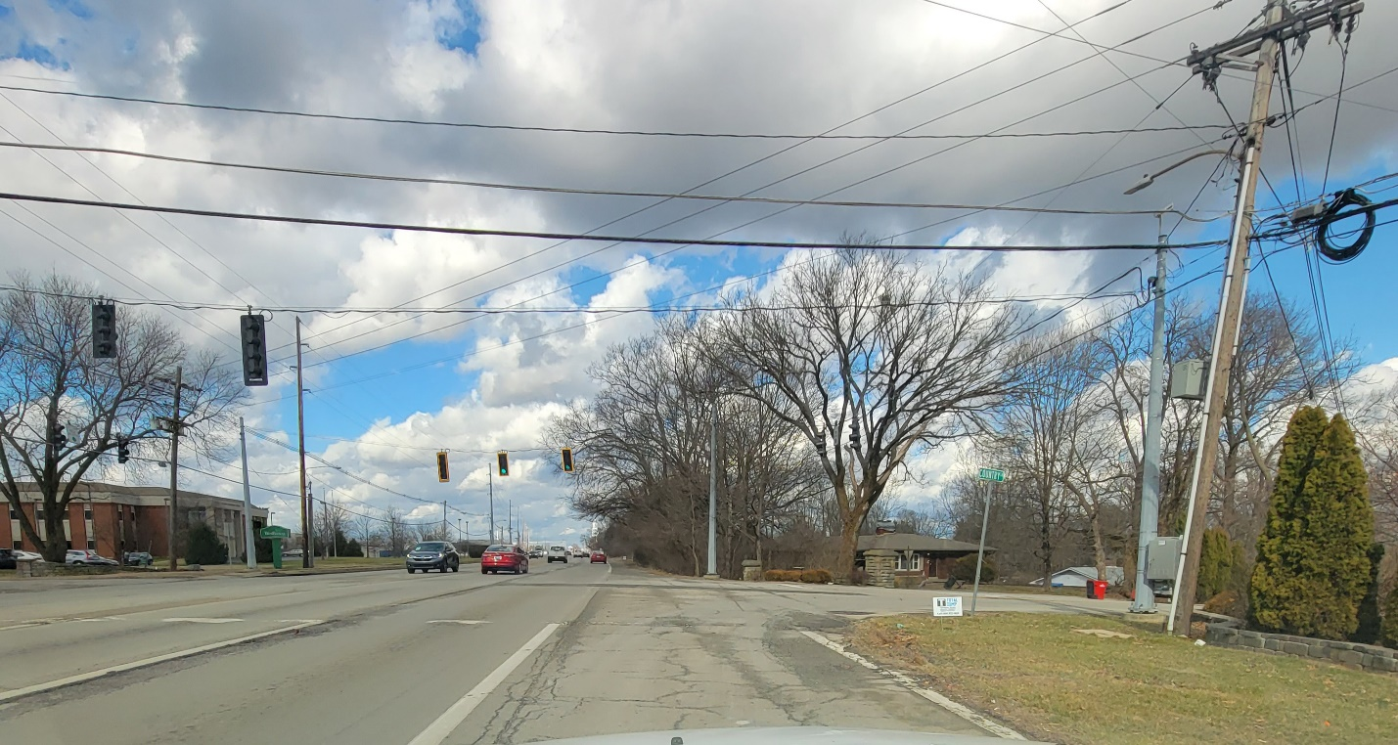

Continue down Country Lane
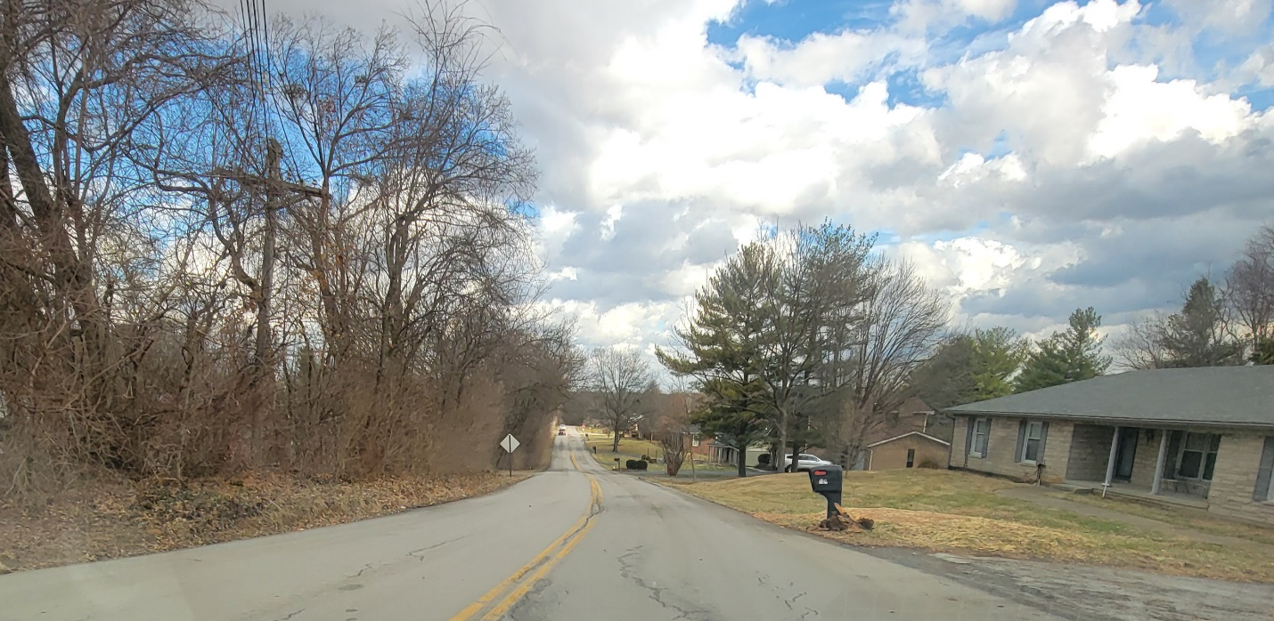
Stop at this intersection, but keep going straight down Country Lane.
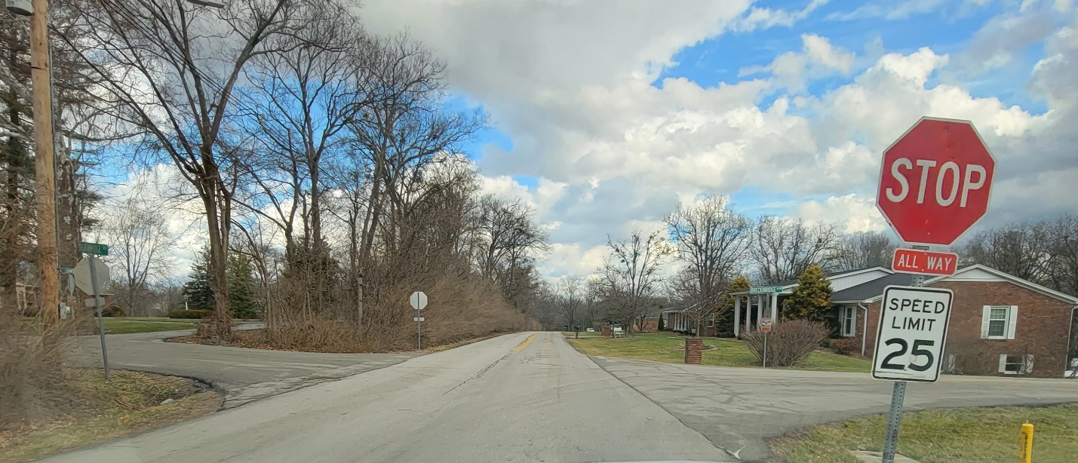

Keep to the right at this fork.
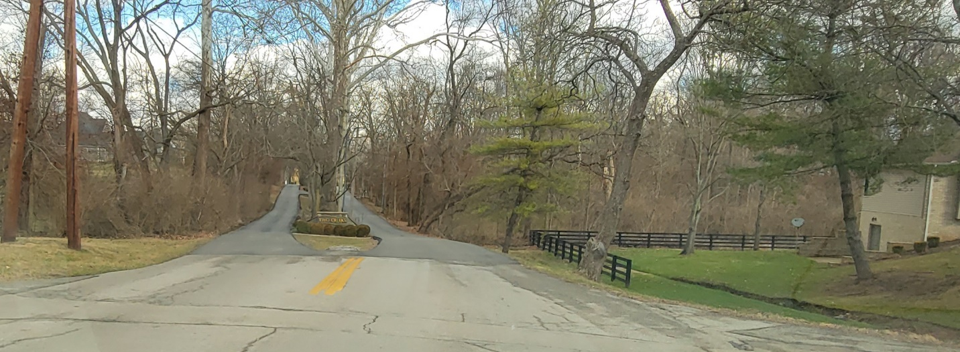
Keep going straight.
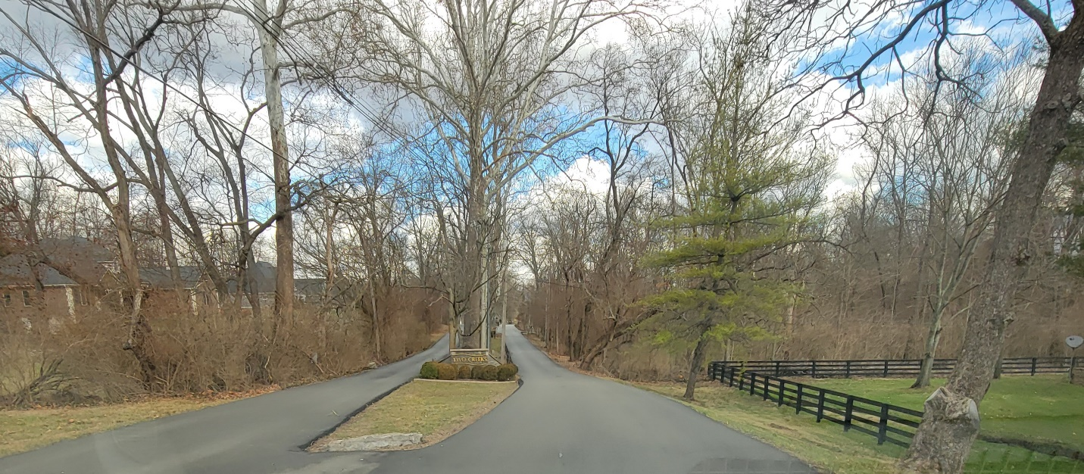
Keep following this road straight.
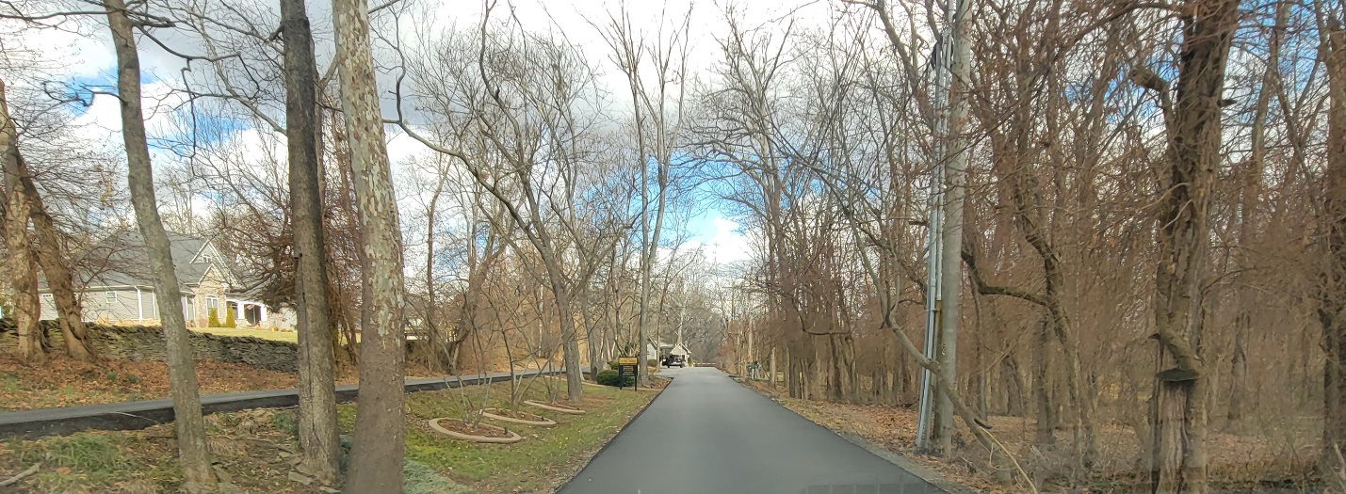
Continue following the road. You will see a guard shack. Continue towards the guard.
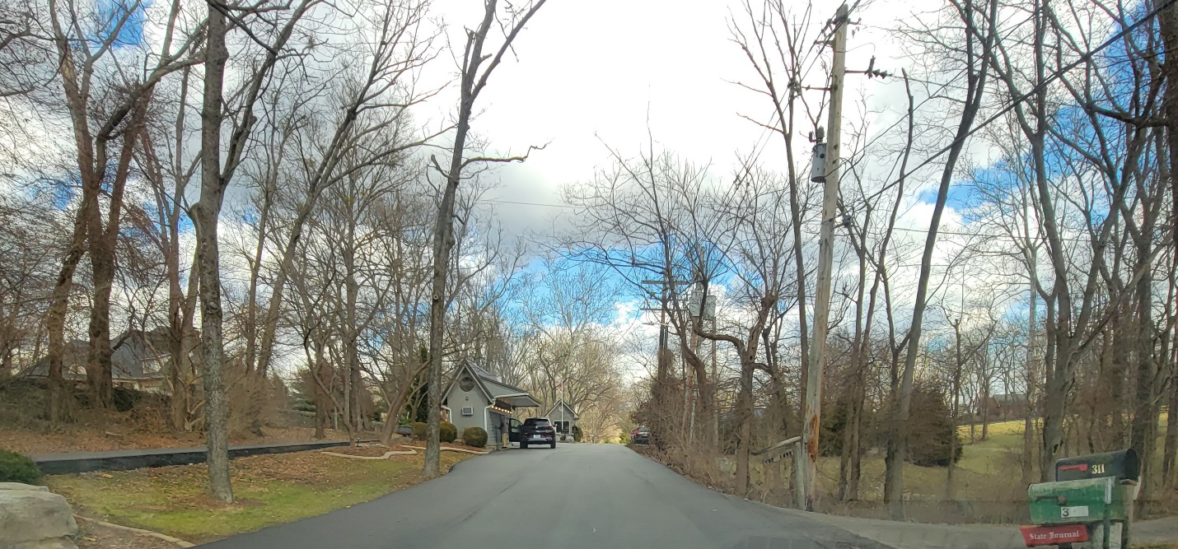

You will need to stop and speak to the guard. Tell them you have arrived for the Bluegrass Writers Conference of Writers at the Frankfort Country Club.

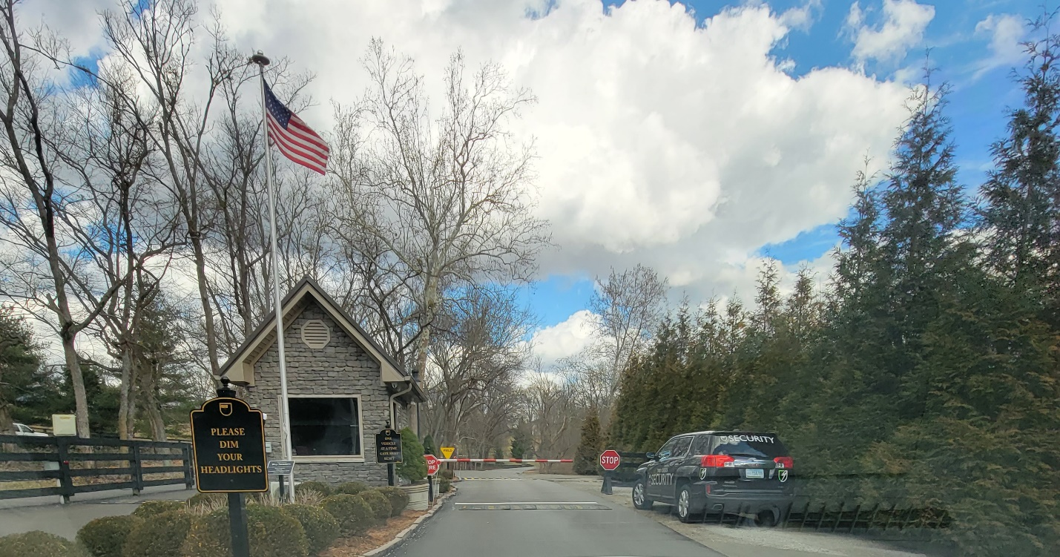

Proceed straight once you have checked in with the guard.
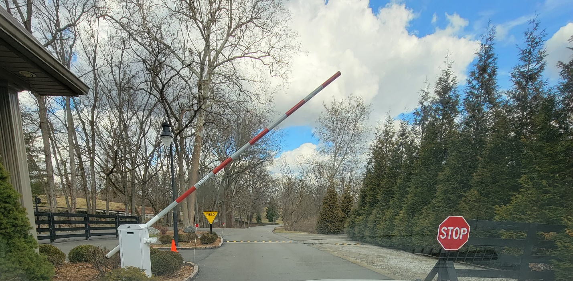
Follow the road you are on.
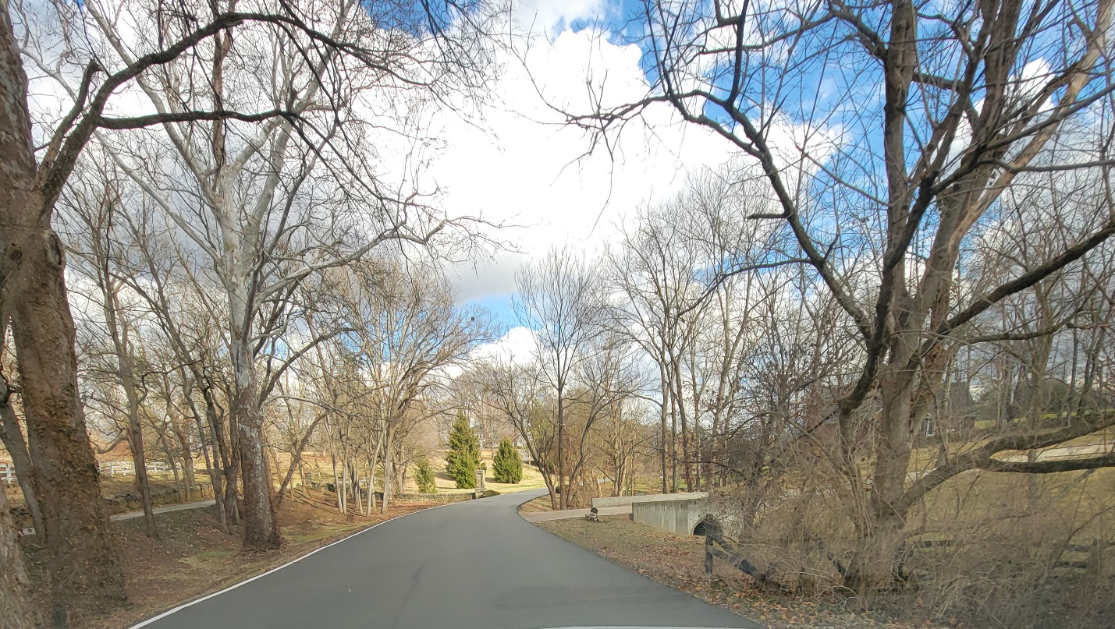

Keep following the road around.
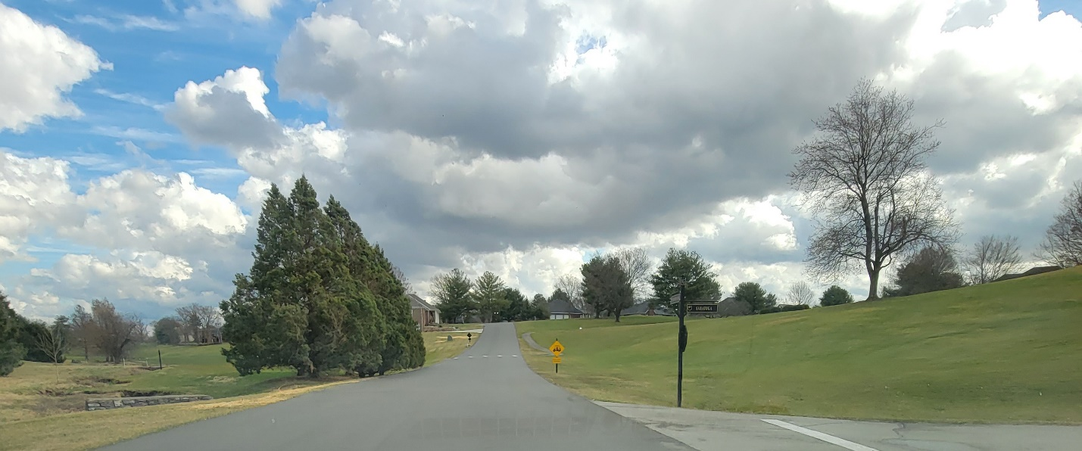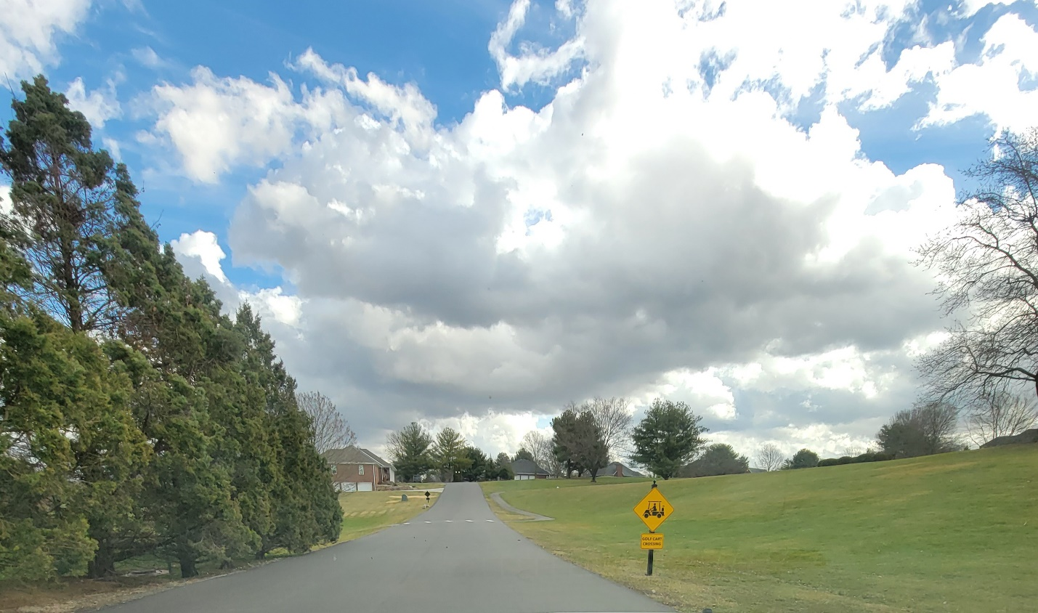

Be mindful of the upcoming split. Keep to the right.

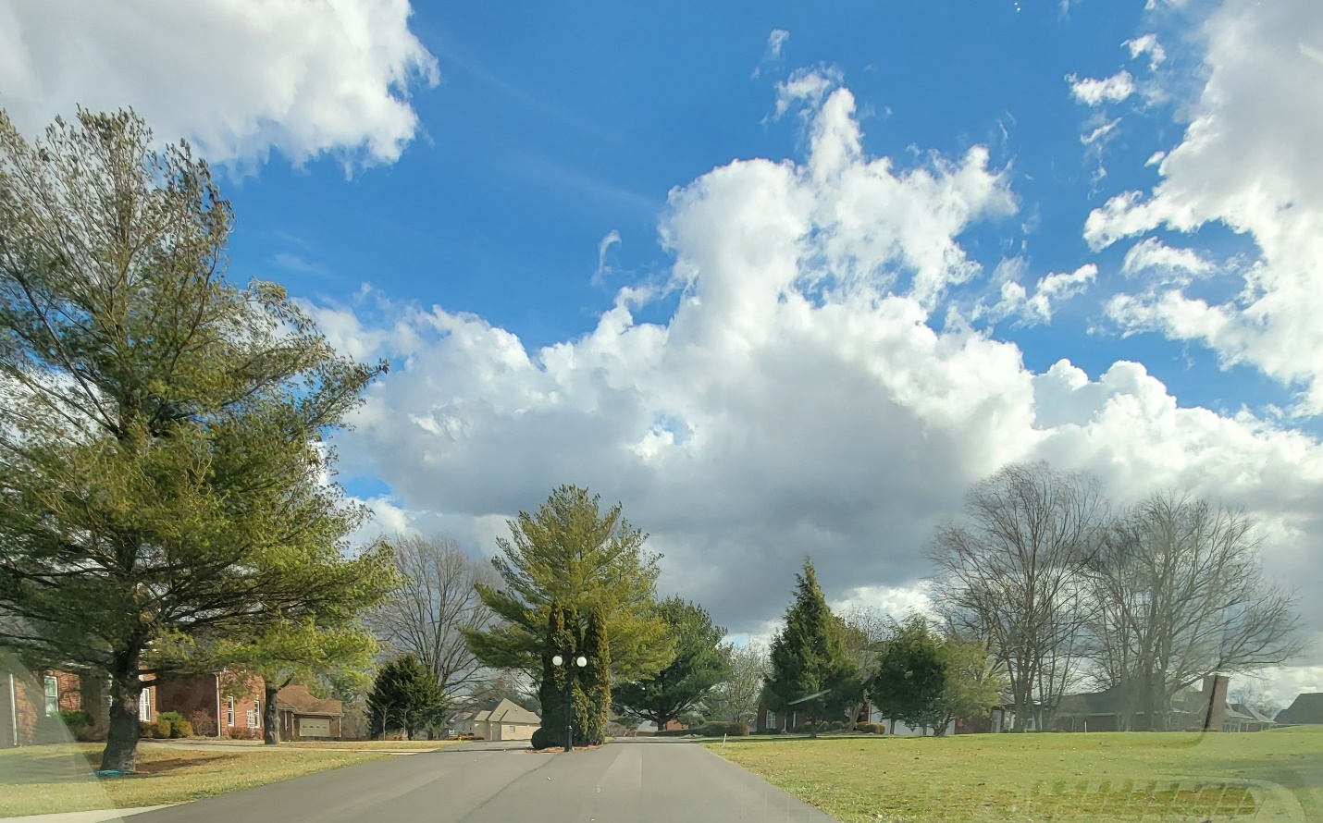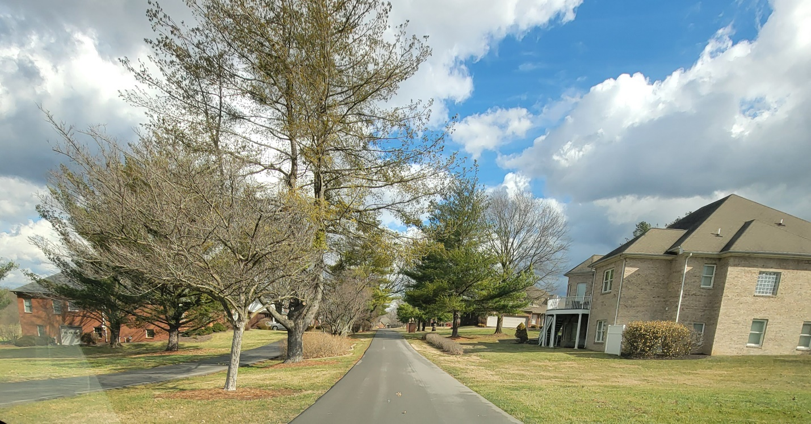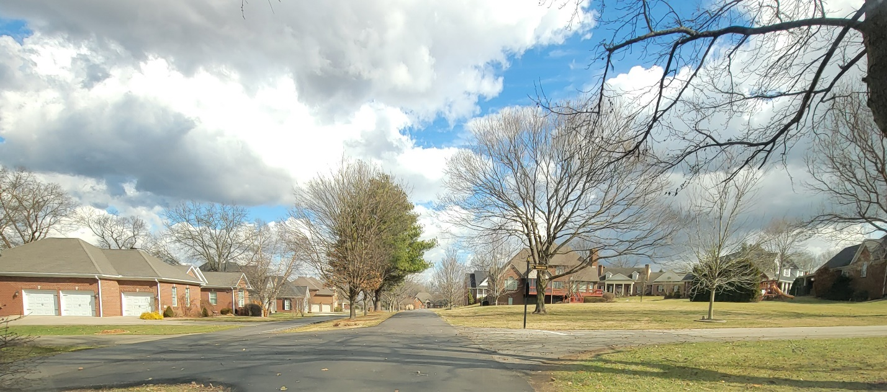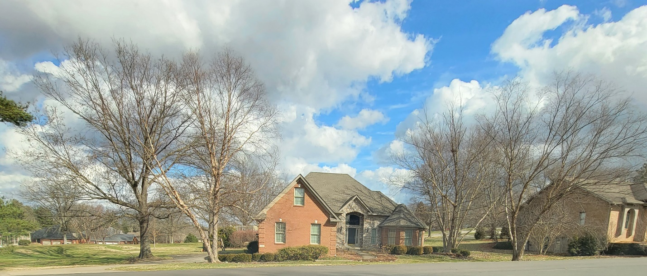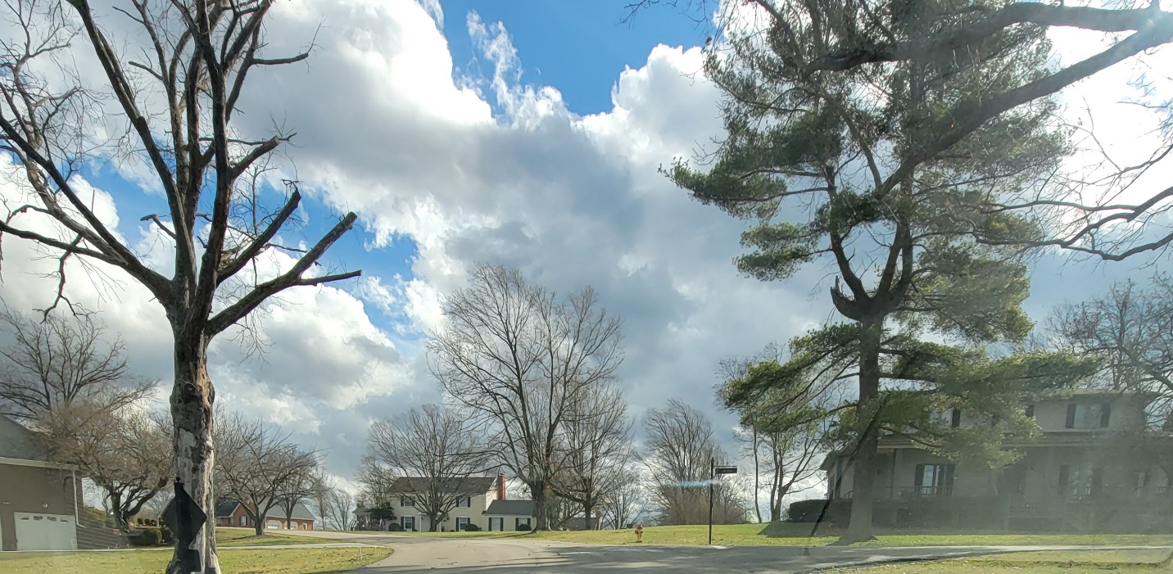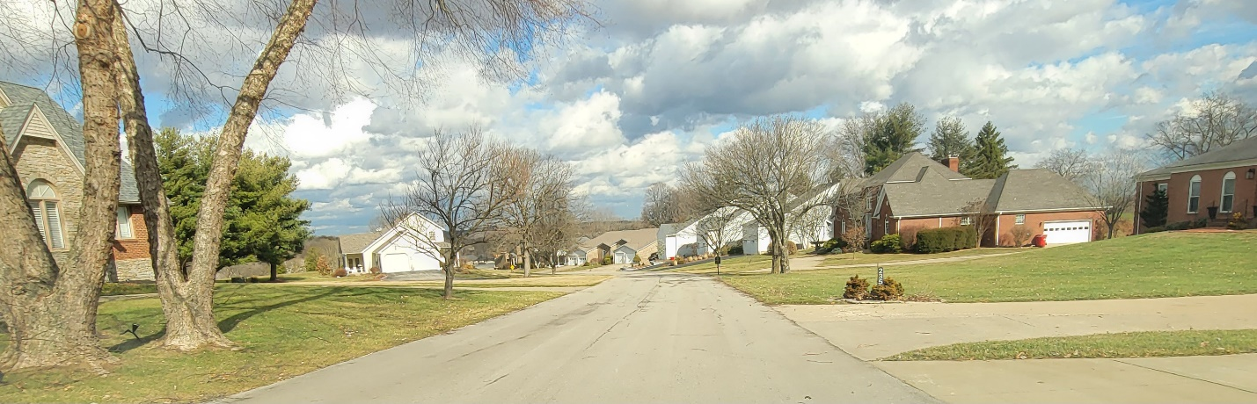

Turn right into the FCC parking lot.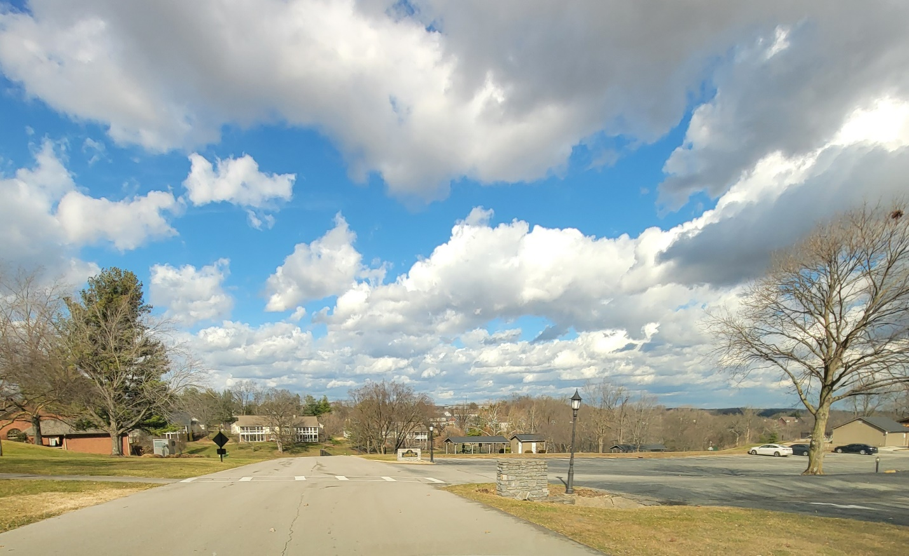

You will enter through the front doors where you can check in with registration.
